**Research Methodology**

**(IN 6910)**

**Assignment**

D.N.H Senevirathna

139180A

Faculty of Information Technology

University of Moratuwa

**Analysis of the research paper “A real-time computer vision system for vehicle tracking and traffic surveillance (Coifman et al., 1998)” using scientific method.**

1. Observation

According to the study by Coifman and coworkers, they have observed that in recent years the increasing traffic congestion on freeways has become a significant problem for the existing vehicle detectors. Furthermore they have noticed that the early solutions such as to lay more pavement and add more lanes to avoid congestion had become less feasible with time. They have noted that existing commercial vehicle detection systems based on video image processing are working well in free-flowing traffic but having difficulties with situations like congestion, shadows and light transitions occur due to partial occlusion of vehicle and also due to the fact that vehicles appearing differently under various light conditions. Therefore they have stated the significance of introducing a feature based tracking system for detecting vehicles under these challenging conditions.

1. Preliminary study

Coifman and coworkers, in their work, have studied about the commercial video image processing systems (VIPS) available at present and stated that most of them are tripwire systems which mimic the operation of loop detectors rather than tracking vehicles. AUTOSCOPE, CCATS, TAS, IMPACTS and TraffiCam (Hockaday, 1991; Hoose, 1992; Chatziioanou et al., 1994; Klein and Kelley, 1996; MNDOT, 1997) are some of the commercial tripwire systems they have studied. They have identified that these available systems do not identify individual vehicles as unique targets and follow their movements in time distinct from other vehicles.

Furthermore, they have studied about third generation video image processing systems which track vehicles by using region based tracking in which vehicles are segmented based on movement. They have considered commercial system such as CMS Mobilizer, Eliop EVA, PEEK VideoTrak, Nestor TrafficVision, and Sumitomo IDET (Chatziioanou et al., 1994; Klein and Kelley, 1996; MNDOT, 1997; Nihan et al., 1995) as third generation VIPS. They have recognized that in situations like occlusion, two different moving targets may become merged by these systems.

They have also studied about recent evaluations of commercial VIPS, and the evaluations has revealed that the current systems had problems with congestion, high flow, occlusion, camera vibration due to wind, lighting transitions between night/day and day/night, and long shadows linking vehicles.

In this research, they have also studied about the algorithm developed to differentiate vehicles from shadows by Chao and coworkers Chao et al. (1996).

Different vehicle tracking strategies from computer vision literature has been studied and discussed in this work and they have been classified as model based tracking, region based tracking, active contour based tracking and feature based tracking. For each of this modal, they have discussed the mechanism used inside and features available along with the limitations of each modal.

1. Problem definition

After the study of existing vehicle detection systems, they have identified the following stringent requirements of a system in order to be an effective traffic surveillance tool.

1. Automatic segmentation of each vehicle from the background and from other vehicles so that all vehicles are detected.
2. Correctly detect all types of road vehicles - motorcycles, passenger cars, buses, construction equipment, trucks, etc.
3. Function under a wide range of traffic conditions - light traffic, congestion, varying speeds in different lanes.
4. Function under a wide variety of lighting conditions - sunny, overcast, twilight, night, rainy, etc.
5. Operate in real-time.

They have stated that many of these criteria still cannot be met by the existing commercial VIPS for monitoring traffic available in the market, and therefore the requirement of traffic surveillance under all conditions.

1. Hypothesis development

In order to address the requirement they identified during the preliminary study, they have proposed a new vehicle tracking system which includes camera calibration, feature detection, feature tracking, and feature grouping modules based on feature based tracking algorithm. They have assumed that the proposed feature based tracking as a means to improve detector performance in congestion and difficult lighting conditions, and also to facilitate new and improved traffic parameters by using true wide-area detection to yield vehicle trajectories.

1. Experimental design

Coifman and coworkers have designed a vehicle tracking system which consists of camera calibration, feature detection, feature tracking, and feature grouping modules. According to their design, the camera calibration is conducted once, offline, for a given location and then, the other modules are designed to run continuously online in real-time.

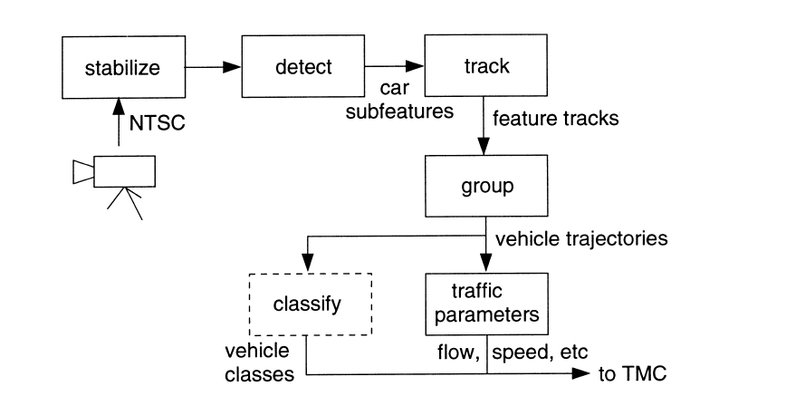

**Figure 1 - Block diagram of the vehicle tracking system**

The above figure 1 shows the block diagram of the proposed system, it contains the planned vehicle classification module to be added in future indicated in dashed lines. Here TMC stands for traffic management center.

They have implemented the vehicle tracker on a network of 13 Texas Instruments C40 digital signal processing (DSP) chips. The computationally heavy operations in the tracking algorithm, convolution in the feature detector and correlation in feature tracker, are placed on the C40 network, while the grouper is run on the host PC.

1. Data Collection

For the testing purposes of the proposed tracking system they have gone through two major phases of testing. First, the system has been tested offline, using pre-digitized video sequences for development purposes such as to analyze errors like false detections, false negatives, and over groupings. Second, the real-time system has been tested on a large data set to see if the system could accurately measure aggregate traffic parameters. During the second phase, the online testing of traffic parameters, they have tested flow, average velocity and density. These parameters have been computed separately for each lane of traffic and are sampled over a 5 min sample period. Since they have noted that generating manual ground truth data is very time consuming and labor intensive, they had used existing loop detectors to verify the vehicle tracker over a large data set.

The vehicle tracker has been tested on approximately 44 lane-hours of video from the Florin Road interchange along State Highway 99 in Sacramento. The test set includes all observed operating conditions: day, night, twilight, long shadows and rain. The final test set included approximately 40,000 vehicle observations which were distributed over 514 samples

1. Data Analysis

The collected data from the proposed system has been analysed and compared against the ground truth data collected. They have calculated the error distribution for velocity, flow and density over 44 lane-hours of data as indicated below,

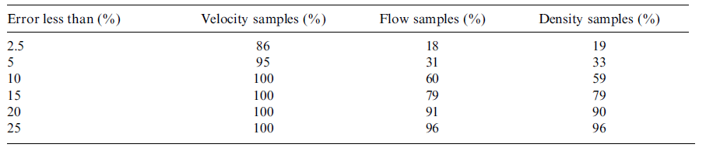

**Table 1 - Error distribution for velocity, flow and density over 44 lane-hours of data**

They have noted that the measured velocity is very accurate by the new system, and the system performance have not shown any significant changes under different conditions, in which the other traditional systems failed.

1. Conclusion

In conclusion, they have stated that the presented vehicle detection and tracking system is capable of operating under challenging conditions like with congestion, occlusion, lighting transitions between night/day and day/night, camera vibration due to wind, and long shadows linking vehicles together, in which existing systems have problems with.

The proposed system has overcome the challenges faced by traditional systems by tracking vehicle features instead of tracking entire vehicles, making the system less sensitive to the problem of partial occlusion. The same algorithm has been used for tracking in daylight, twilight and nighttime conditions, it is indicated as self-regulating by selecting the most salient features for the given conditions.

They have also noted that the resulting vehicle trajectories could be used to provide traditional traffic parameters as well as new metrics such as lane changes. Furthermore they have stated that the trajectories can be used as input to more sophisticated, automated surveillance applications,

**References:-**

Coifman, B., Beymer, D., McLauchlan, P., Malik, J., 1998. A real-time computer vision system for vehicle tracking and traffic surveillance. Transp. Res. Part C Emerg. Technol. 6, 271–288.

Chao, T., Lau, B., Park, Y., 1996 Vehicle detection and classification in shadowy traffic images using wavelets and neural networks. In: Transportation Sensors and Controls: Collision Avoidance, Traffic Management, and ITS, SPIE Proc. Vol. 2902, pp. 136±147.

Chatziioanou, A., Hockaday, S., Ponce, L., Kaighn, S., Staley, C., 1994. Video Image Processing Systems Applications in Transportation, Phase II. Final Report, California Polytechnic State Univ., San Luis Obispo, CA.

Hockaday, S., 1991. Evaluation of Image Processing Technology for Applications in Highway Operations-Final Report, California Department of Transportation Technical Report 91-2. California Polytechnic State University.

Hoose, N., 1992. IMPACTS: an image analysis tool for motorway surveillance. Traffic Engineering and Control 33(3), 140±147.

Klein, L., Kelley, M., (Hughes Aircraft Company), 1996. Detection Technology for IVHS: Final Report, FHWA Report No. FHWA-RD-95-100.

MNDOT, 1997. Field Test of Monitoring of Urban Vehicle Operations Using Non-Intrusive Technologies, FHWA Report No. FHWA-PL-97-018.

Nihan, N., Leth, M., Wong, A., 1995. Video Image Processing for freeway Monitoring and Control: Evaluation of the Mobilizer, Washington State Department of Transportation Report No. WA-RD 398.1/TNW 95-03